# Create an Agreement Procedure

Service Level Management

**Purpose**

An Agreement is where a Service Level Target’s expected compliance percentage and review period are defined. The Agreement is linked to the Service Target.

**Related Policy**

* [IT Service Management Policy](https://sharepoint.jackson.com/sites/itsmsd/servicelevelmanagement/Shared%20Documents/Pre%20December%202019/SLM%20Documents/Policy%2C%20Process%2C%20Procedures/SLM_Service%20Level%20Management%20Process.doc?d=wa1eaba53e1dc4b30abda2a0886981cc9)

**Audience**

The following groups are responsible for adhering to this document:

* Service Level Management

**Procedure**

|  |  |
| --- | --- |
| Step | Action |
| 1 | To access Service Level Management in Remedy to verify if a viable Agreement already exists, follow the instructions below:   1. In the Remedy system, Select the Applications tab on the side. 2. Select “Service Level management”. 3. Select Service Level Management Console”.      1. On the “SLM Console” tab, click the “Folders” drop down-arrow. 2. Click “Standard Services” 3. For Agreements related to Aggregate Service Targets, click on the “Aggregate Service Targets TM” folder.     For Agreements related to Platinum services, click the “Monitored” folder.     1. Click on the “Agreements” tab. This will show a list of existing Agreements that have been created. *In this example, an Agreement for a service related to an Aggregate Service Target is being shown.* 2. To put the Agreements in alphabetical order, click the “Title” field on the blue bar.      1. If you need to review an existing Agreement, highlight the specific Agreement and click the “View” button.      1. If a viable Agreement already exists that matches the criteria found in the Metric Data Definition spreadsheet *(see* ***Appendix B****)* for the specified service, you are done with this procedure. 2. If the desired Agreement does not exist, continue to Step 3. |
| 2 | **To Create an Agreement**   1. Click the “Create” button.      1. Enter information in the following fields:    * **Title:** Name the Agreement.   See ***Appendix A*** for the standard naming convention.   * + **Description:** Enter the full Service Name.   + **Expiration Date:** Should be a date far into the future. Currently 12/31/2037 11:59:00 PM is the furthest time that can be used.   + **Notification Date:** Select a date two months before the expiration date that was entered.   + **Business Service:** Select from drop down menu. This will be the service name as it appears in Remedy.   . |
| 3 | To set the Compliance Target percentage and relate the Agreement to a Service Target:   1. On the “Related Service Targets” tab located on the lower half of the screen, fill in the following fields:    * **Compliance Target:** This needs to match the “Compliance Minimum” percentage found in the Metric Data Definition spreadsheet *(see* ***Appendix B****).*    * **Compliance At Risk:** A percentage value that considers the Service Target to be in danger of not meeting the compliance target. This needs to match the “Compliance Target” percentage found in the Metric Data Definition spreadsheet *(see* ***Appendix B****).*      1. Click the “Relate” button.      1. Search for a corresponding Service Target in the “Title” field:    * Use the % sign as a wild card.    * For Agreements related to an Aggregate Service Targets, use the corresponding tier name in which the service you are creating an Agreement falls under.    * For Agreements related to Platinum Service Targets, use a part of the name of the service you are creating the Agreement for.      * + Select the correct Service Target that matches the business unit and compliance   target that is being created.     1. Highlight the correct Service Target and click the “Relate Selected Record” button.     ***Note:*** *If more than one Service Target is linked to the same Agreement, the “Weighted Value” field can be increased to make one of the Service Targets ranked more significant than the other(s). The system evaluates the Service Targets and their weights, then assigns each Service Target a weighted contribution percentage. This allows an Urgent priority Service Target to be more important than a Low priority Service Target. At this time, only one Service Target is being linked to an Agreement and the “Weighted Value” is defaulted to “1”.* |
| 4 | To set the Review Period:   1. On the “Review Periods/Penalties Rewards” tab, click the arrow button by “Add Review Period”. 2. Select “Daily” 3. Click the arrow again. 4. Select “Monthly (starting the 1st)”. |
| 5 | The “Milestones” and the “Contracts/Attachments” tabs are not being used at this time. No information needs to be added in either tab.   1. Click the “Save” button.     The “SLM Console” screen will appear. Follow **Step 2** d) through h) of this procedure to locate the Agreement that has just been created and continue to Step 7.  ***Note****: If a “Warning” alert appears after clicking the “Save” button, click “OK”. Follow Step 8 of the* ***SLM Create Service Targets Procedure*** *to rebuild the Service Target.* |
| 6 | Review the “Build Status” of the Agreement that has just been created:   1. “Built Successfully” or “Build in Progress” are expected. If the status is “Build in Progress”, click the “Refresh” button until the status updates to “Built Successfully”. 2. Once the status of “Built Successfully” appears, a Master Record will need to be created.   For more information see:  [Create a Master Record Procedure](https://confluence.jacksonnational.com/pages/viewpage.action?spaceKey=CPENABLE&title=Create+a+Master+Record&preview=/610910994/610912849/Create%20a%20Master%20Record%20Procedure.docx)     1. If “Could Not Be Built” appears, highlight the Agreement and click the “Build” button.      1. Click the “Yes” button. 2. Click the “Refresh” button until the status changes to “Built Successfully”. 3. If the status returns to “Could Not Be Built”, review the information in the Agreement to make sure it is correct. Correct the data and try to build it again. If that does not work, then delete the agreement and create a new one.   ***Note:*** *An alternative to setting up Agreements from scratch is to use the “Copy” feature. See* ***Appendix B*** |

**Appendix A – Agreement Naming Convention**

The Agreement name should follow this format:

***CIU-JET-AAA-XX***

***AAAA*** – Service Name

***Note:*** *Use the service name that is found in the* [*Appendix D7 Application Maintenance*](https://sharepoint.jackson.com/sites/itsmsd/servicelevelmanagement/Shared%20Documents/Appendixes/Jackson%20-%20TML%20-%20Appendix%20D7%20-%20Service%20Levels%20%20Tower%207%20Application%20Maintenance%20(Jackson%20TM%20Final%20)%20(MLB%20Edits).xlsx?d=w1d807f2962e54acb96824568f5cac77d) *or*

[*Metric Database CPI Data*](https://sharepoint.jackson.com/sites/itsmsd/servicelevelmanagement/_layouts/15/start.aspx#/Shared%20Documents/Forms/AllItems.aspx?RootFolder=%2Fsites%2Fitsmsd%2Fservicelevelmanagement%2FShared%20Documents%2FPre%20December%202019%2FMDD%20Database%20Files&FolderCTID=0x012000C3EC5FEE7B19F646BACB9A57478C774E&View=%7B527EAB19%2D8D4A%2D47E6%2DACE1%2DCA631A3D99D0%7D)*. These will match the Service names that appear in Remedy*.

**XX** – 99

For Agreements related to Platinum Service Targets, or Gold and Silver Aggregate

Service Targets.

**XX** – 98

For Agreements related to Bronze Aggregate Service Targets.

***Note:*** *There is a set Compliance Target for each service and a Minimum Compliance Target as well. Due to a current restriction on the Master Record in which only two characters can be displayed as the Compliance Target on the SLA Report, 99 is the standard Compliance Target that is used.*

***Note:*** *If a service name contains any text in parenthesis, do not include the parenthesis in the Agreement name. If the title contains parenthesis use a hyphen between the service name and the acronym.*

**

***Example:*** *Cash Disbursement System (CDS) should be:*

*CIU-Cash Disbursement System-CDS-99*

***Note:*** *The compliance target percentage number is needed in the title as it is used to auto-populate the “Compliance Target” field when the Master Record is created.*

For more information see:

[Create a Master Record Procedure](https://confluence.jacksonnational.com/display/CPENABLE/Create+a+Master+Record?preview=/610910994/610912849/Create%20a%20Master%20Record%20Procedure.docx)

***Note:*** *Legacy applications that were identified as Platinum in 2019 contain extra characters that represent the acronym for the Business Unit. The acronym is no longer required in the Service Target title.*

**Appendix B – Use “Copy” option to create a new Agreement**

An alternative to creating an Agreement from scratch is to use the “Copy” feature.

1. Find and highlight an existing Agreement that has a compliance target (see **Step 3** a) of this procedure) that is the same as the new Agreement to be set up.

**Example:** If you need to create a new Agreement to be linked to the Aggregate Gold Service Target, find an Agreement that is already linked to the Aggregate Gold Service Target.

1. Click the “Copy” button.



1. Type in the Agreement name. See ***Appendix A*** for the naming convention.
2. Click the “OK” button.

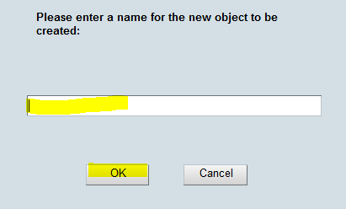

1. The screen will reset itself with the list of Agreements. Highlight the Agreement that was just created and click the “View” button.



1. The following fields will need to be edited.

* **Business Service:** Select the correct service from the drop-down menu.
* **Description:** Copy and paste the Business Service name into this field. The

“Tech Service” suffix can be deleted.

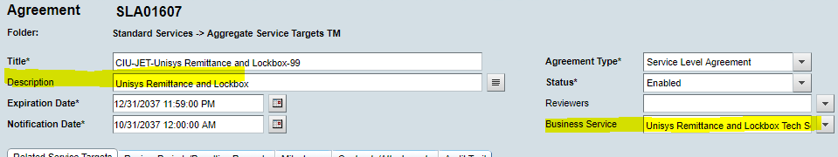

* **Compliance Target:** This will only need to be edited if a Platinum service was

copied. Not all Platinum compliance targets are

the same.

* + - **Related Service Target:** This will only need to be edited if a Platinum service

was copied, as Platinum services each have an

individual Service Target.

* Highlight the Service Target
* Click the “Unrelate” button
* Reply “Yes” to the message that appears.

.

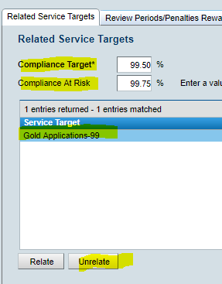

* Click the “Relate” button
* Type in the partial name of the Service Target to be related, using “%” as wild cards.
* Highlight the Service Target name when it appears
* Click the “Relate” button.

1. Click the “Save” button.

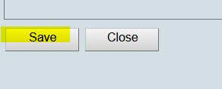

1. Ensure that the status of the new Agreement is “Built Successfully”. If not, see Step 6 c) through f) of this procedure.

**Modification**

The following associates can make modifications to this document:

* Manager, Service Level Management
* Director, IT Service Management
* Vice President, Service Delivery
* Chief Technology Officer, PGDS

|  |  |
| --- | --- |
| Service Level Management Process | |
| Responsible Party: Sharla Piepkow, Manager, Service Level Management Approving Authority: Rob Kolm, Director, IT Service Management | Date Created: 09/05/2017 Last Modified: 05/05/2020 Last Reviewed: |